Exhaust ventilation is failing us, especially in Multifamily: How 2019 Title 24 Addresses This

By Mark Lundberg, Field Controls Director of Engineering

Exhaust, Supply, and Balanced. These are the three methods that the California energy code recognizes to satisfy the mechanical ventilation requirement for all new buildings and additions of over 1,000 square feet. Common industry practice is to use the simplest and least expensive of these – Exhaust only ventilation. New tract homes comply by setting a bathroom exhaust fan to run continuously at ~50 cfm, and new multifamily units typically do the same. These exhaust systems are designed to remove moisture from a bathroom, not provide full-building fresh air, and the 2019 energy code will make some changes.

Title 24 has adopted ASHRAE’s 62.2 standard for whole building ventilation in residential buildings and 62.1 for commercial buildings. Until the 2019 code, the method used for ventilation didn’t matter; exhaust, supply, and balanced ventilation all checked the box and met the mandatory requirement. But the 2019 code will recognize for the first time that there is a better way to ventilate than exhaust only ventilation.

Note that all supply/balanced fans ventilation systems will be required to include MERV 13 filtration on them starting with the 2019 residential code. Central ducted returns will also have to incorporate MERV 13 filtration beginning when the 2019 residential code takes effect. We need to be prepared for these changes.

Why is Exhaust Ventilation Failing us?

Exhaust ventilation relies on building science that is flawed – that by sucking air out of the house, fresh air is brought in to replace it. This much is true, but by relying on this principle to keep the building occupants breathing healthy air, we expose them to potential harm:

- The air coming in to replace the exhausted air is coming from small holes in the envelope all around the house and is uncontrolled. It may be coming from the garage if it shares a wall with the house, where all kinds of dust and chemicals are present. Or it may be coming from the dog run or the attic, so the air brought in by an exhaust fan is not the air we would choose to breathe.
- The air is unfiltered
- The air is poorly distributed throughout the house. It may be all coming in through one relatively large opening and thus only ventilating that portion of the house. It may not get into bedrooms with closed doors at night, where the kids are sleeping, getting ready for their next day at school. Especially as houses get larger and multi-story, the exhaust ventilation strategy becomes less effective at ventilating the whole space.
- The pressure in the house is negative, which has been shown to lead to increased condensation risk and combustion appliance backdrafting. Positive pressure is better, and neutral pressure is best for occupant comfort and energy efficiency.

Supply & Balanced Ventilation Strategies

Put in terms of good, better, best, ventilation strategies are exhaust, supply, balanced, respectively. The following table illustrates the pros and cons of each type. Supply ventilation can be accomplished by use of a through-the-wall supply fan in several places in the house. Another supply strategy is a central-fan-integrated (CFI) system, which uses the central air handler and a damper-controlled supply duct to bring in fresh air intermittently throughout the day and distribute it throughout the existing ductwork. Balanced ventilation is best accomplished using HRVs and ERVs – dedicated appliances that have built-in fans to exhaust air from the house and supply fresh air from outside at the same rate. These systems have the added benefit of tempering the incoming outside air through a heat exchanger that reduces heating and cooling demand associated with the incoming outside air. Besides the use of HRV and ERV systems, balanced ventilation can be accomplished through the use of supply and exhaust fans in tandem.

Comparison of Ventilation Types
 | Exhaust | Supply | Balanced
Cost | Low | Low + | High
Air Quality | Low | High | High
Distribution of Air | Low | Medium (through wall) to High (CFI) | High
Pressure in the House | Negative | Positive | Neutral
Energy Use | Low | Low | Medium

CABEC is very focused on energy use, so let’s address that here. Exhaust fans typically are very low-wattage. Panasonic’s WhisperGreen Select, for instance, uses 3 watts at 50 cfm, which is truly amazing. At 26 kWh per year, operating this exhaust fan will cost the homeowner about $4.00. Their WhisperSupply fan brings in filtered air from controlled locations and uses 8 watts at 40 cfm, which means 70 kWh per year and about $10.00 cost to operate. The exhaust and supply fans are very low energy use, but they draw in air from uncontrolled sources and can create negative or positive pressure.

Turning to the improved air quality options, CFI and HRVs, we trade increased energy use for improved indoor air quality. A CFI system operating in supply mode uses the central furnace fan to bring in fresh air and distribute it through the ductwork, as shown in Figure 1.

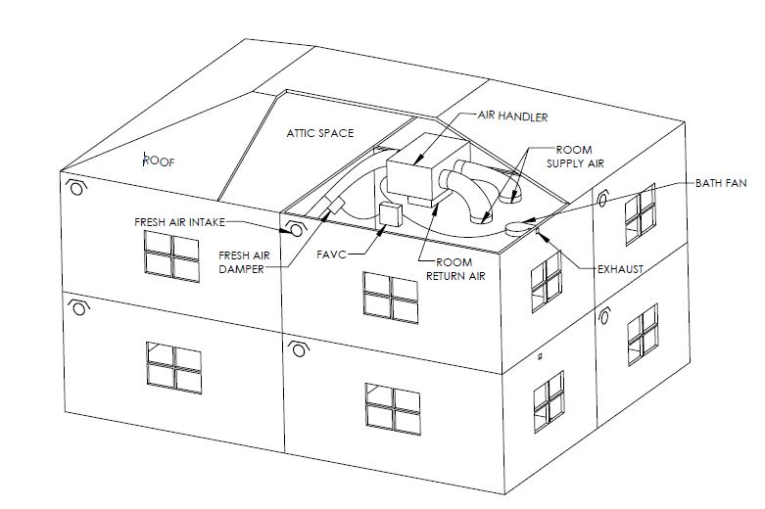
FIGURE 1: Multi-family Balanced Ventilation Using Field Controls FAVC

These systems are typically operated on an intermittent schedule, such as 10 minutes on and 20 minutes off. Plus, they monitor the heating and cooling cycles and open the damper during those cycles whenever possible to save the extra fan energy. Thus they operate an incremental 1/3 of the time as a maximum, but they use the full wattage of the central fan, so they have higher energy usage than smaller exhaust and supply fans. Studies show a typical home may use 500-1,000 kWh with a CFI system or $75-$150 per year, similar to a standard refrigerator. This may be a small price to pay for a family concerned about indoor air quality and health. Note that the Residential Title 24 software does not penalize compliance for adding a CFI system to the model. The residential software does not currently support (2016 code) CFI mechanical ventilation, so it is modeled as default and the installing contractor does the CF-2R form and the HERS rater verifies the cfm on the CF-3R form. All intermittent mechanical ventilation systems must be listed on the CEC’s list maintained here http://www.energy.ca.gov/title24/equipment_cert/imv/IMV_Certified_List.xls.

HRVs and ERVs improve on CFI ventilation by recovering the heat from the exhausted air to temper the incoming air. They have dedicated fans with lower energy usage than central air handlers, so the energy penalty is lower than a CFI system. In many climate zones in California, HRVs can produce compliance credit, as the energy savings from the heat recovery function exceeds the energy penalty for the fan energy, and the fan efficiency exceeds that of the standard reference house. Energy usage from Field Controls FC95HRV is 89 watts at 60 cfm (0.5 static pressure drop), or 780 kWh per year or $120 to operate, offset by the avoided space conditioning energy from the heat recovery function. The modeling software puts an HRV in the reference standard home when you put one in your model, with the same heat recovery effectiveness and 1.2 W/cfm, so if you can specify a unit that is more efficient than this, you can achieve compliance credit. Note that HRVs can be installed as stand-alone ventilation appliances with exhaust and supply ducts spread out throughout the home or can be ducted into the central ductwork as a supplemental system to the central air handler.

Title 24 & Mechanical Ventilation

In low-rise and high-rise multifamily buildings, balanced ventilation will be a mandatory requirement under the 2019 energy code in California, with one exception. This is in recognition of the fact that exhaust only ventilation with walls shared between units can result in bringing neighbors’ air into a unit, rather than fresh outside air. In fact, the CASE team proposing this change to the code referenced a 2016 New York study that found that 20% of the air coming into a multifamily unit came not from outside, but from neighboring units and corridors. So new multifamily units will be required to have balanced ventilation, with one exception – if the builder can prove air infiltration of less than 0.3 cfm per square foot of envelope at 50 pascals (through a blower door test). The uncertainty of a blower door test after construction may encourage builders to take a hard look at upgrading to balanced ventilation.

The 2019 code made no change to ventilation strategy requirements for single-family homes, but the multifamily balanced ventilation requirement in the 2019 residential code may provide a pilot study for this strategy that leads to changes to single-family ventilation code standards in future.

Options for Meeting the Multifamily Balanced Ventilation Requirement

As we look ahead to the 2019 multifamily energy code, there are a number of ways to meet the requirement for balanced ventilation that will allow our clients to avoid the need for a blower door test:

- CFIs paired with exhaust fans in every unit
- Supply fans paired with exhaust fans in every unit
- Central exhaust and supply fans serving multiple units
- HRVs in every unit

Case Study: The UCenter on Turner, Columbia, Missouri, multifamily project

Objective: This multi-family project had issues with the existing ventilation system. One issue was the inability to piggyback the introduction of outside air with the run time of the system as effectively as possible. The other was an infiltration issue due to damper leakage that forced them to specify an additional backdraft damper as a “safety net” against infiltration, hence inflating the cost basis of the job.

Solution: The engineers decided to use Field Controls Fresh Air Ventilation Controls (FAVC) due to the FAVC’s ability to manage runtime of the system to better manage incoming humidity levels. Field Controls dampers allowed the engineers to manage infiltration. The FAVC central-fan-integrated mechanical ventilation system allowed the building designer to meet ASHRAE 62.1 fresh air requirements, while saving energy and managing humidity through the FAVC’s sophisticated controller.

Synopsis: With the superior ability of the Field Controls FAVC to manage runtime of the system the engineer could manage incoming humidity levels and reduce energy usage of the ventilation system. The FAVC combined with Field Controls dampers, allowed the engineer to completely offload the backdraft damper off the specification and their ongoing basis of design, yielding an automatic cost savings on this job and all of their jobs going forward, giving more value to their customers.

CABEC & Indoor Air Quality

By adding indoor air quality through supply or balanced ventilation and filtration to the services we provide the architect and homeowner, we can add more value to each project. Just meeting code for minimum cfm of ventilation may not be enough for every client. Those with children with allergies and asthma, people who work from home, those caring for elderly parents and caregivers, and people who are more conscious of health and wellness will be very interested in what their CABEC consultants recommend to make their living space healthier and more productive for their family. Adding mechanical ventilation and filtration to the scope of our work is a smart idea and we would be wise to start now, before the 2019 code forces us to.

Sherman, M. and Walker, I. 2007. “Energy Impact of Residential Ventilation Standards in California,” LBNL 61282. Lawrence Berkeley National Laboratory, Berkeley, CA. Study found impact of typical central air handler ventilation systems to be over 750 kwh/yr.
https://efiling.energy.ca.gov/GetDocument.aspx?tn=222202, page 18

